Integration Partner Due Diligence Questionnaire - Bulk Data Extract

Completed by
Date completed

Instructions
This Due Diligence Questionnaire (DDQ) must be completed in full by all organisations seeking to consume data via our Bulk Data Extract interface.

All responses are subject to review by Medicus Health. Approval is not guaranteed and may be withdrawn at any time if obligations are not maintained.

Supported use cases for IM1 Bulk Extracts:
- Targeted extracts for specific reporting use cases (e.g. CH-IS extracts)
- Broad data extracts for transfer to a data warehouse (e.g. PHM/analytics)
- Direct care planning where the organisation has a legitimate relationship with the patient population

IM1 Bulk must NOT be used for:
- Direct care delivery by third-party organisations (use IM1 Transactional instead)
- Patient-facing services where patients view their own records (use IM1 PFS instead)
- Data migration purposes (use the NHS Data Migration standard)

Please complete all sections. Where a question is not applicable, enter 'N/A' and provide a brief explanation.

Section 1 - Organisation Details

Legal name of organisation
Registered company number
Registered address
Primary contact name and role
Primary contact email address
Primary contact telephone number
Data Protection Officer (DPO) name and contact details
Clinical Safety Officer (CSO) name and contact details
Organisation's ICO Registration Number

Section 2 - Intended Use & Legal Basis
All consumers must provide a clear definition of the intended use of the data, along with the legal basis for extraction.

Describe the intended use of the extracted data in full

Include the specific purpose, the population(s) affected, and the clinical or operational need
Classify the intended use

Select one: Direct Care / Indirect Care / Both. Refer to the definitions on the Medicus Help Centre.
State the legal basis under UK GDPR for processing this data
Is there a Data Provision Notice or statutory obligation that requires this extract?

If yes, provide reference and attach a copy as a supporting document.
Will this extract feed a multi-purpose system (i.e. used for both direct and indirect care)?

If yes, explain how Role-Based Access Control (RBAC) is used to segregate access within the consumer system.

Section 3 - Data Extract Definition
The extract definition must conform to the principle of minimisation of data egress. Consumers must only request the minimum data fields required for the defined use case.

Which reporting data tables and fields are required?

List all tables and fields. Attach a detailed field mapping as a supporting document.
Is a full extract or delta extract required?

Full extract: complete dataset at each run. Delta extract: initial full load followed by incremental changes.
Provide a statement on the risk of 'singling out' (re-identification of individuals from the data)

Reference ICO guidance on singling out. Describe mitigations in place.
Provide a statement on the risk of 'linkability' (the mosaic effect)

Reference ICO guidance on linkability. Describe mitigations in place.

Section 4 - Data Protection & Information Governance
All consumers must maintain the certifications and standards listed below. Evidence must be provided for each.

ISO 27001 certification — certifying body name, certificate number, and expiry date

Must be issued by a UKAS-approved accreditation body. Statement of Applicability (SoA) must cover all relevant processing activities. Attach certificate.
Cyber Essentials Plus certification — certifying body, certificate number, and expiry date

Scope must cover all processing activities related to this extract. Attach certificate.
DSP Toolkit — organisation code, assessment year, and attainment level

Must be at 'Standards Exceeded' level. Provide a link to or screenshot of the published submission
Provide a copy of or link to your current Data Protection Impact Assessment (DPIA)

The DPIA must describe data flows end-to-end, including sub-processors and access controls.
Detail the authentication controls in place for access to data derived from this extract

Must meet or exceed NIST AAL2. Describe the mechanism (e.g. MFA type, identity provider).
Describe your procedures for protecting sensitive data from illegal breach

Include detection, containment, notification, and remediation processes.
What is your Data Retention Policy for data received via this extract?

Must include a mechanism for cascading GDPR obligations (including deletion requests) from Data Controllers to your systems and any sub-processors.

Section 5 - Data Residency & Sub-processing
All processing and sub-processing must remain within the United Kingdom unless an explicit exception has been agreed with the Data Controllers. Medicus Health shares no liability for any breach of this obligation.

Provide a statement confirming that all data will remain within the United Kingdom throughout the end-to-end data flow

Include technical details: storage location, processing infrastructure, and cloud provider regions.
List all sub-processors that will have access to data received via this extract

Include name, role, country of processing, and contractual basis.
Confirm there will be no secondary transfers of data without explicit Data Controller approval

Secondary transfer means any transfer of data to a party not identified in the DPIA or this DDQ.
How is data encrypted at rest once downloaded from MESH or SFTP?

Provide technical details of the encryption standard, key management, and storage environment.

Section 6 - Transmission Mechanism
Select your preferred transmission mechanism below. You must complete the relevant sub-section only. Both SFTP and MESH are supported; select the option appropriate to your technical environment.

6A - SFTP (Consumer-hosted)
The SFTP server must be hosted by the consumer on the public internet (not HSCN). Medicus will authenticate using SSH public/private key pairs (ed25519 algorithm). Please add the Medicus public key for each environment to your SFTP server.

SFTP server hostname / IP address

Provide details per environment if multiple (e.g. Integration Test, Production)
SFTP server port
SFTP username
SFTP directory path (where files will be deposited)
Confirm you have added the Medicus UAT public key to your SFTP server

UAT key: ssh-ed25519 AAAAC3NzaC1lZDI1NTE5AAAAIHmuZOGYiUQVyOsso8SDhx8GmRhsno2oNmuBM0tE5WPg support@medicus.health
Confirm you have added the Medicus Staging public key to your SFTP server

Staging key: ssh-ed25519 AAAAC3NzaC1lZDI1NTE5AAAAIJDCqiL07SBXzIFwxgloWrhkLH5mXLHfr9dIc8/EOF7q support@medicus.health
Do you require Medicus IP addresses to be allowlisted on your firewall?

If yes, confirm the following IP addresses have been added:

UAT - 3.11.49.207
Staging - 3.8.218.189
Production - 18.135.65.70

The public key for our production environment will be provided once assurance is complete.

6B - MESH
MESH is available for NHS England organisations only. It is not available for Channel Islands or private organisations. Files will be sent from the local organisation's MESH mailbox using Workflow ID: GFTD_INIT.

Provide your MESH Mailbox ID
Confirm you are able to receive files via MESH Workflow ID: GFTD_INIT

Section 7 - File Encryption
File-level encryption is optional but recommended. Medicus uses PKCS#7 / S/MIME ZIP Encryption (AES-256 with RSA/ECC public key). To enable encryption, provide your public key certificate below.

Do you require file-level encryption for the delivered ZIP files?

Yes / No
If yes — provide your public key certificate (certificate.pem)

Generate using: openssl req -new -x509 -key private.pem -out certificate.pem -days 3650. Attach certificate.pem as a supporting document or paste the certificate content here.
Confirm your private key is stored securely and will not be transmitted to Medicus

The private key must remain on your server and is used solely to decrypt files received from Medicus.
What is the expiry date of your certificate?

Certificates generated with the default command expire after 10 years. You are responsible for renewing and providing a new certificate before expiry.

Section 8 - Extract Enablement Information
When enabling your extract, healthcare providers are shown information on screen about what the enabling the extract will do and any considerations they should have made as part of enabling the extract.

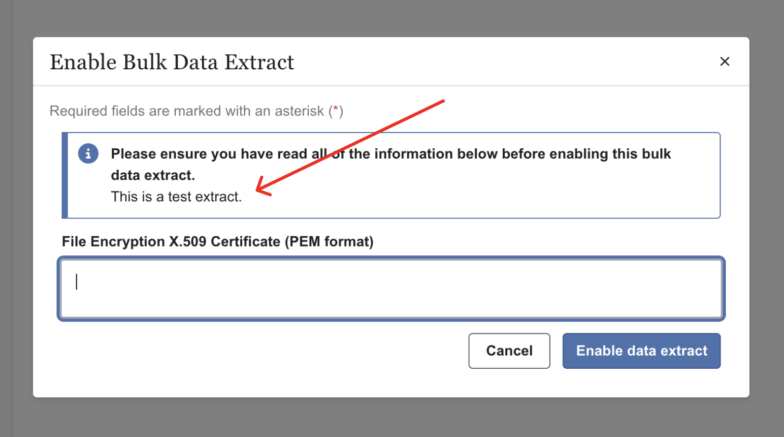

Please provide the copy that you would like us to include below:

Section 9 - Supporting Documents
The following documents must be submitted alongside this DDQ. Tick each box to confirm the document is attached.

Required Document | Reference / Notes
Completed DDQ (this document)
Data Protection Impact Assessment (DPIA) | Must cover end-to-end data flows
ISO 27001 Certificate | UKAS-accredited body; valid SoA
Cyber Essentials Plus Certificate | Scope covering all processing activities
DSP Toolkit submission evidence | Standards Exceeded level
Data Provision Notice or statutory basis document | If applicable
Data Retention Policy | Must include GDPR cascade mechanism
Field mapping for extract definition | See Section 3
Public key certificate (certificate.pem) | Required only if file encryption enabled

