Integration Partner Due Diligence Questionnaire - Transactional API

Completed by
Date completed

Instructions
This Due Diligence Questionnaire (DDQ) must be completed in full by all organisations seeking to consume data via our Transactional API.

All responses are subject to review by Medicus Health. Approval is not guaranteed and may be withdrawn at any time if obligations are not maintained.

Supported use cases for our Transactional API:
- Direct care delivery by third-party organisations

Our Transactional API must NOT be used for:
- Bulk data extracts (use IM1 Bulk instead)
- Patient-facing services where patients view their own records (use IM1 PFS instead)
- Data migration purposes (use the NHS Data Migration standard)

Please complete all sections. Where a question is not applicable, enter 'N/A' and provide a brief explanation.

Section 1: Organisation Details

Legal name of organisation
Registered company number
Registered address
Primary contact name and role
Primary contact email address
Primary contact telephone number
Data Protection Officer (DPO) name and contact details
Clinical Safety Officer (CSO) name and contact details
Organisation's ICO Registration Number

Section 2: Intended Use
All consumers must provide a clear definition of the intended use of the API.

Describe the intended use of the integration

Include the specific purpose, the population(s) affected, and the clinical or operational need

Section 3: API Endpoints
Consumers must only request the API endpoints required for the defined use case.

Which API endpoints are required?

List all endpoints
Application or user restricted?

Provide justification

Section 4: Data Protection & Information Governance
All consumers must maintain the certifications and standards listed below. Evidence must be provided for each.

ISO 27001 certification — certifying body name, certificate number, and expiry date

Must be issued by a UKAS-approved accreditation body. Statement of Applicability (SoA) must cover all relevant processing activities. Attach certificate.
Cyber Essentials Plus certification — certifying body, certificate number, and expiry date

Scope must cover all processing activities related to this extract. Attach certificate.
DSP Toolkit — organisation code, assessment year, and attainment level

Must be at 'Standards Exceeded' level. Provide a link to or screenshot of the published submission
Provide a copy of or link to your current Data Protection Impact Assessment (DPIA)

The DPIA must describe data flows end-to-end, including sub-processors and access controls.
Detail the authentication controls in place for access to data obtained from Medicus

Must meet or exceed NIST AAL2. Describe the mechanism (e.g. MFA type, identity provider).
Describe your procedures for protecting sensitive data from illegal breach

Include detection, containment, notification, and remediation processes.

Section 5: Data Residency & Sub-processing
All processing and sub-processing must remain within the United Kingdom unless an explicit exception has been agreed with the Data Controllers. Medicus Health shares no liability for any breach of this obligation.

Provide a statement confirming that all data will remain within the United Kingdom throughout the end-to-end data flow

Include technical details: storage location, processing infrastructure, and cloud provider regions.
List all sub-processors that will have access to data retrieved from Medicus

Include name, role, country of processing, and contractual basis.
Confirm there will be no secondary transfers of data without explicit Data Controller approval

Secondary transfer means any transfer of data to a party not identified in the DPIA or this DDQ.

Section 6 — Supporting Documents
The following documents must be submitted alongside this DDQ. Tick each box to confirm the document is attached.

Required Document | Reference / Notes
Completed DDQ (this document)
Data Protection Impact Assessment (DPIA) | Must cover end-to-end data flows
ISO 27001 Certificate | UKAS-accredited body; valid SoA
Cyber Essentials Plus Certificate | Scope covering all processing activities
DSP Toolkit submission evidence | Standards Exceeded level

Section 7 - App Enablement Information
When enabling your app, healthcare providers are shown information on screen about what the enabling the app will do and any considerations they should have made as part of enabling the app.

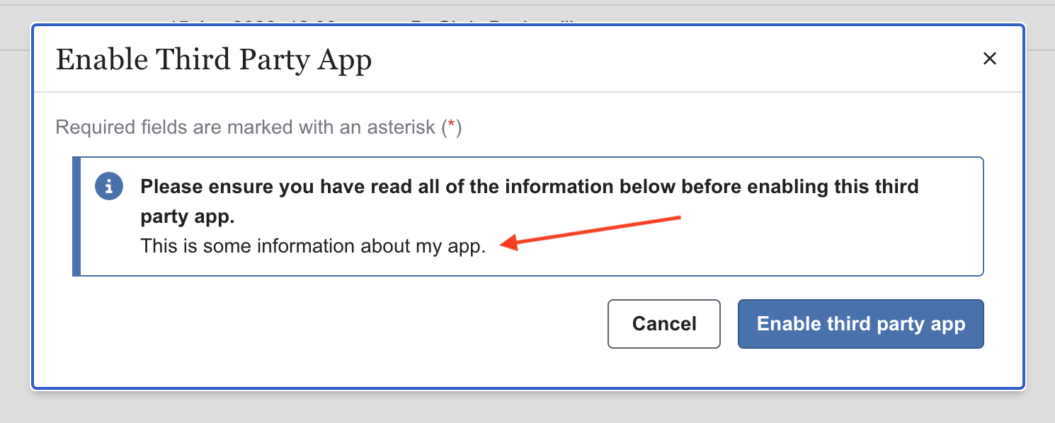

Please provide the copy that you would like us to include below:

